Learning Path for Demand Forecasting with MLForecast

What is Demand Forecasting?
Demand forecasting involves predicting future demand for a product or service using historical data. Accurate forecasts help businesses manage inventory, supply chains, and resources efficiently.

Key Concepts to Learn

a. Data Preprocessing
Objective: Prepare the raw data for modeling by cleaning, transforming, and feature engineering.
Steps:
- Handle missing values in critical columns (e.g., units_sold, total_price).
- Aggregate data if required (e.g., weekly or monthly sales trends).
- Generate time-based features such as day_of_week, month, quarter, or holidays.
- Create lagged features like previous week’s units_sold or rolling averages.
- Normalize or scale continuous variables such as total_price and base_price.

b. Input/Output Format
- Input: Historical sales data with features like time (week), store ID (store_id), product ID (sku_id), pricing, and promotional indicators.
- Output: Predicted sales values (units_sold) for future weeks, helping optimize inventory and supply chain decisions.

c. Cross-Validation
- What is it? A method to split the dataset into training and testing sets multiple times to evaluate model performance.
- Use time-series cross-validation, where training data always precedes testing data chronologically.

d. Single Model vs. Ensemble
- Single Model: Uses a single predictive algorithm like XGBoost or LightGBM.
- Ensemble: Combines multiple models to improve prediction accuracy (e.g., stacking or bagging).

e. Hyperparameter Tuning
Objective: Optimize the model’s parameters to improve performance.
Methods:
- Grid Search: Tests all combinations of predefined parameters.
- Random Search: Tests random combinations of parameters.
- Bayesian Optimization: Dynamically selects the next best set of parameters based on results.
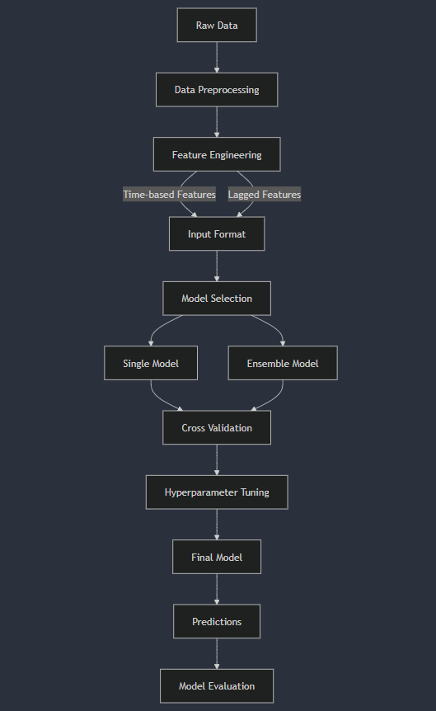

MLForecast Overview
MLForecast is a Python library that simplifies time-series forecasting using machine learning models.
Key Features:
- Handles time-series data preprocessing such as lags and rolling averages.
- Automates feature generation for time-series forecasting.
- Integrates with popular ML models like LightGBM and XGBoost.
Required Libraries:
! pip install mlforecast lightgbm pandas scikit-learn

Step-by-Step Example

Step 1: Import Required Libraries
import pandas as pd
from mlforecast import MLForecast
from lightgbm import LGBMRegressor
from sklearn.model_selection import TimeSeriesSplit

Step 2: Load the Dataset
data = pd.read_csv('your_dataset.csv') # Replace with your dataset path
data['week'] = pd.to_datetime(data['week'])
data = data.sort_values(['store_id', 'sku_id', 'week'])
print(data.head())

Step 3: Data Preprocessing
# Feature engineering
data['day_of_week'] = data['week'].dt.dayofweek
data['month'] = data['week'].dt.month

# Ensure target is numeric
data['units_sold'] = data['units_sold'].astype(float)

Step 4: Define Cross-Validation
tscv = TimeSeriesSplit(n_splits=5)

for train_idx, test_idx in tscv.split(data):
train_data = data.iloc[train_idx]
test_data = data.iloc[test_idx]
print(f"Train data range: {train_data['week'].min()} - {train_data['week'].max()}")
print(f"Test data range: {test_data['week'].min()} - {test_data['week'].max()}")

Step 5: Build the Model
forecast = MLForecast(
models=[LGBMRegressor()],
freq='W', # Weekly frequency
lags=[1, 2, 3, 4], # Lags for units_sold
lag_transforms={1: ['mean'], 4: ['std']}
)

forecast.fit(data, target_col='units_sold', date_col='week', id_col=['store_id', 'sku_id'])

Step 6: Make Predictions
future_weeks = pd.date_range(data['week'].max(), periods=10, freq='W')
future_df = pd.DataFrame({'week': future_weeks})
predictions = forecast.predict(future_df)
print(predictions.head())

Step 7: Evaluate the Model
from sklearn.metrics import mean_squared_error

actual = test_data['units_sold'].values
predicted = predictions['units_sold'].values
rmse = mean_squared_error(actual, predicted, squared=False)
print(f'RMSE: {rmse}')

Documentation Template

a. Data Preprocessing
Goal: Convert raw data into a model-ready format.
Tools: Pandas, NumPy, and MLForecast utilities.

b. Cross-Validation
Goal: Validate the model using past data for realistic performance estimates.

c. Model Tuning
Example of Grid Search for Tuning Hyperparameters:
from sklearn.model_selection import GridSearchCV
param_grid = {
'num_leaves': [31, 50],
'learning_rate': [0.01, 0.1],
}
grid_search = GridSearchCV(LGBMRegressor(), param_grid, scoring='neg_mean_squared_error', cv=tscv)
grid_search.fit(train_data.drop(['units_sold'], axis=1), train_data['units_sold'])
print(grid_search.best_params_)

d. Utility Functions
Use helper functions to automate repetitive tasks like feature engineering and model evaluation.

Next Steps
- Run the above example end-to-end.
- Experiment with different lags and features.
- Try additional models like XGBoost.
- Tune hyperparameters to observe performance improvements.
- Analyze results and apply them to business scenarios.

